**FINAL YEAR PROJECT**

**GAME DESIGN DOCUMENT**



**[UE2]**

**Developer - Winston (212668S)**

**Developer - Jiaxu (210681N)**

**Developer - Yokawa**

**Artist - XinYing (212035K)**

**Artist - Kerrin (213155U)**

**Artist - John (Admin No)**

**TABLE OF CONTENTS**

**1.0. Game Overview 3**

1.1. Introduction 3

1.2. Story Synopsis 3

1.3. Genre and Target Platform 3

1.4. Target Market 3

1.5. Unique Selling Points 4

**2.0. Game Mechanics 4**

2.1. Game Play 4

2.2. Game Characters 4

2.3. Game Elements 5

2.4. Game Flow 6

2.5. Input System/Key Features 6

2.6. Scoring System 8

**3.0. Level Designs 9**

3.1. Level 1 9

**4.0. User Interface 11**

4.1. Heads Up Display 11

4.2. Game Menus 11

**5.0. Appendix 12**

5.1. Appendix A – Character Sketches 12

5.2. Appendix B – Background Sketches 14

5.3. Etc 15

# Game Overview

## Introduction

Daybreak is an immersive stealth sim about an infiltration into a post-war vampire base in a warehouse. The player is set to complete objectives in a stealth puzzle hybrid while interacting with the vampire mafia and the world around them.

## Story Synopsis

Post war 1950s: the end of the first opium war. During the war, many soldiers smoked opium, a common, cheap drug. However, mixed with blood and a little tear gas from the war, turned into Nostrum(drug made by an unqualified person/nosferatu), a potent mix that made the soldiers more excited than usual, bloodthirsty from the heat of battle.

The end of the war sparked many controversies, mainly the under table deals between governments, sending off the young to fight in a decade long conflict. Few returned and those who did were traumatised by the horrors from the field. They returned with heavy hearts, turning to substances, abuse and ultimately taking their own life, all to escape the trauma they faced. Veterans had no ability to return to their former lives and ended up joining gangs that give them the regime and violence of the system they are unfortunately at-home with.

The protagonist is a middle-aged nurse turned government operative after becoming stricken with the country’s first recorded and covered-up case of second hand vampirism, upon her exposure to non-lethal dosages of Nostrum by her late husband who constantly smoked it after the war. Being under the influence has made the protagonist resistant to the drug, yet being able to resist the sun and not be blood crazed like the other vampires.

The generals of the army, left with grace and honour after their contributions to the war. Now desperate for money and power, they used their knowledge of the drug to control their soldiers, who now turned mindless and bloodcrazed after their withdrawal. It was a crude and ugly process that created thrulls that could only perform menial tasks.

## Genre and Target Platform

Describe the genre of your game: role-playing, first-person shooter, adventure, action or hybrid of any of those. Target platform: Web, PSP, PS3, XBOX 360,Nintendo DS, etc.

The genre is stealth action, with fantasy horror, immersive sim, played in third person with an orbit camera to provide better camera angles. It is made for the PC with twin-stick controls, with primarily keyboard and mouse input, further controller input can be added.

## Target Market

Define your target audience

Our target audience is teens to young adults, aged 13-25.

The target market is set for vampire enthusiasts, as part of the horror and stealth genre. The art style is relative to the film noir aesthetic.

## Unique Selling Points

Realistic stealth capabilities, the player has to manage line of sight, loudness as well as visibility to avoid detection, or to distract enemies enough for them to ignore the player’s presence.

Stealth game with destructible environments, contrary to other stealth games where the environment is solid and no flashy actions can destroy walls.

Immersive play on a lighting engine, where the player can manipulate light sources to darken locations or to expose certain locations to increase visibility.

Complex AI behaviour, they live their own lives and routines during the game’s time, where each of them has their own individual work and tasks as well as needs. The world lives on with or without the player’s involvement.

# Game Mechanics

## Game Play

Gameplay should be slow, analytic and tactical. Due to the player having low health and slow. The player should traverse the level carefully to reduce enemies finding their position. The player should observe the environment to find suitable locations of movement or interactables to use to their advantage. Combat should be avoided unless necessary, with as many advantages as possible to reduce the chance of death.

## Game Characters

The player has low health, and a fairly slow walk speed without access to a sprint. They have the ability to teleport, on a cooldown. The player has 4 inventory slots, with the ability to drop items, pick up items and use them as needed. There is a preallocated slot for rocks, meant for distracting enemies by throwing.

Human: Normal Humans hired by the mafia to perform simple chores like cleaning the factory and producing products, they work with fear of being attacked by the thrulls around the factory, but continue working as they are paid with products they make to fulfil their addiction. They are usually scrawny and cowardly, hungry and desperate for money to survive. The mafia exploited the less fortunate for their menial labour.

Thrull: They were once humans,who overdosed on too much product and mutated into a mad creature, easily aggravated by the smell of blood. Takes damage from the sun but does not have self preservation to avoid it.

Vampire: Military veterans who worked alongside the baron, trusted enough to have authority over the workers, and strong enough to control thrulls. They wield guns due to their firearm knowledge and proficiency with hand to hand combat. They are also large in stature, commanding others to do their bidding. Takes damage from the sun, will avoid it at all costs

Mafia Baron: the pillar of the mafia society. Once a military general during the war, now leveraging Nostrum and abusing his power and knowledge of the drug to fuel his business in the mafia. He is an old man, clinging onto life with life support, yet strong due to the drug flowing through his veins.

## Game Elements

Describe information such as special abilities, power ups, items, etc. You may also describe enemies that are not the main boss.

Player abilities

* Teleport: The player can activate the ability, aim at a location they wish to teleport to, then release the aim button. They will teleport to the location after the teleport animation, during which their movement is frozen
* X-ray: the player can activate this ability to highlight enemies on the map for a short period of time, allowing them to know where enemies are even if they are out of the player’s normal range of sight, which will help players plan their way forwards
* Eating Bodies to regain health. A strong but situational ability to help regain lost health as well as dispose of human bodies. The player is locked in place for a long period of time, leaving them vulnerable to attacks.
* Enhanced strength: allowing the player to drag bodies around, hiding them or disposing of them. Carrying such a bulky body slows the player down as well as makes a lot of noise, as well as preventing the player from using any items until the body is dropped. As such, this is a high risk skill that has to be utilised carefully.

Objects and interactables

* Silver dagger: the player’s default melee weapon. They spawn in with the dagger already in their inventory
* Lighter: can be used to light objects such as explosive barrels on fire. Players will spawn with the lighter in their inventory
* Explosive barrel: explode a few seconds after being set on fire or shot with a gun, dealing damage to everything in the explosion radius. Can be prevented from exploding if the player uses a fire extinguisher to put it out
* Fire extinguisher: a heavy weapon found in the level. Players can use it as a melee weapon, as well as use it to put out fires. Does not run out of foam
* Wooden crate: can be used as cover and may block paths. The player can break wooden crates using heavy weapons or with gunshots to open new pathways. They drop a wooden stake upon being broken, which can be used to one-shot vampire enemies
* Stake: Dropped when the player breaks a wooden crate. They can be used to kill thrulls easily
* Revolver: A revolver with 12 bullets. Multiple can be found in the level. They cannot be reloaded and will be destroyed once they run out of ammo
* Crowbar: A weapon found in the level

## Game Flow

Give details of the flow chart of your game.

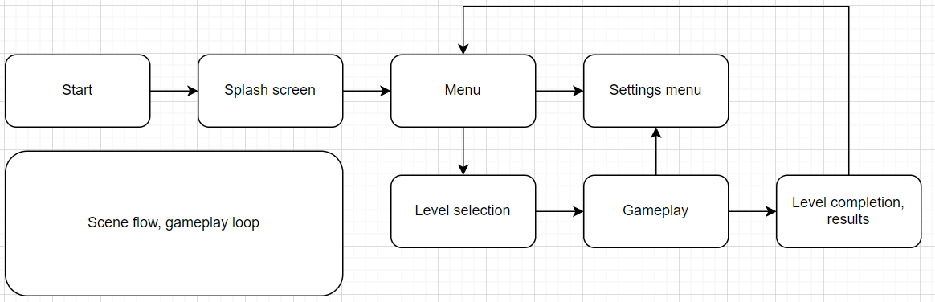

## Input System/Key Features

What are the key inputs? Is it using a keyboard? Is it using a mouse? You should draw a diagram to make it clearer.

WASD- Movement

C - Crouch

E - Environment Interaction

G - Grab Dead Enemy

F - Consume Dead Human

Q - Open Inventory

P - Open Pause Menu

Tab - Open Objective Hud

RMouse - Aim

LMouse - Attack/Shoot

V - Activate Teleport( Right Click when activated to Teleport)

X - Toggle SeeThrough

## Scoring System

Objectives, kills and time taken account for the majority of the game, with some level of score changes based on whether you have been seen by/alerted guards.

Objectives are graded on whether you complete them and whether it is a major objective. The time taken between clearing objectives also functions to balance the scores, encouraging a faster clear time within the level or thorough preparation to clear all the objectives within a short period of time by lining up all favourable clear conditions.

Stealth score is highly encouraged as it serves to reduce active combat, by initiating stealth kills, environmental kills and accidents, you can kill enemies without being put to blame, thus rewarding preparation as well as creativity. Disposing bodies also increases the score as it reduces the traces that could lead the NPCs to detect you.

Combat should not be actively discouraged, thus you merely gain less score from combat and direct murder, with around half the score given instead. Taking damage would reduce scores as well. Thus direct combat is riskier and serves no additional purpose.

# Level Designs

## Level 1

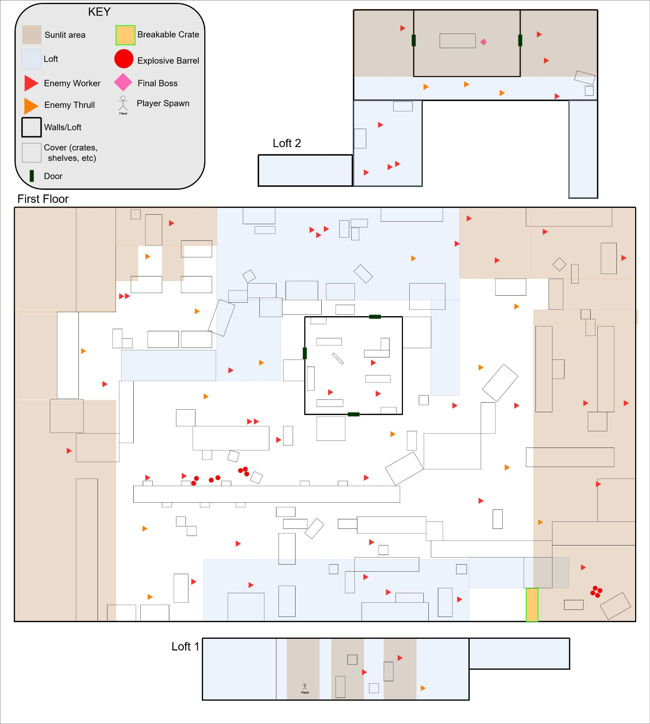

Objective: Locate and kill the boss, then “escape” the level by going to an exit

Provide line maps of the path the player will take.

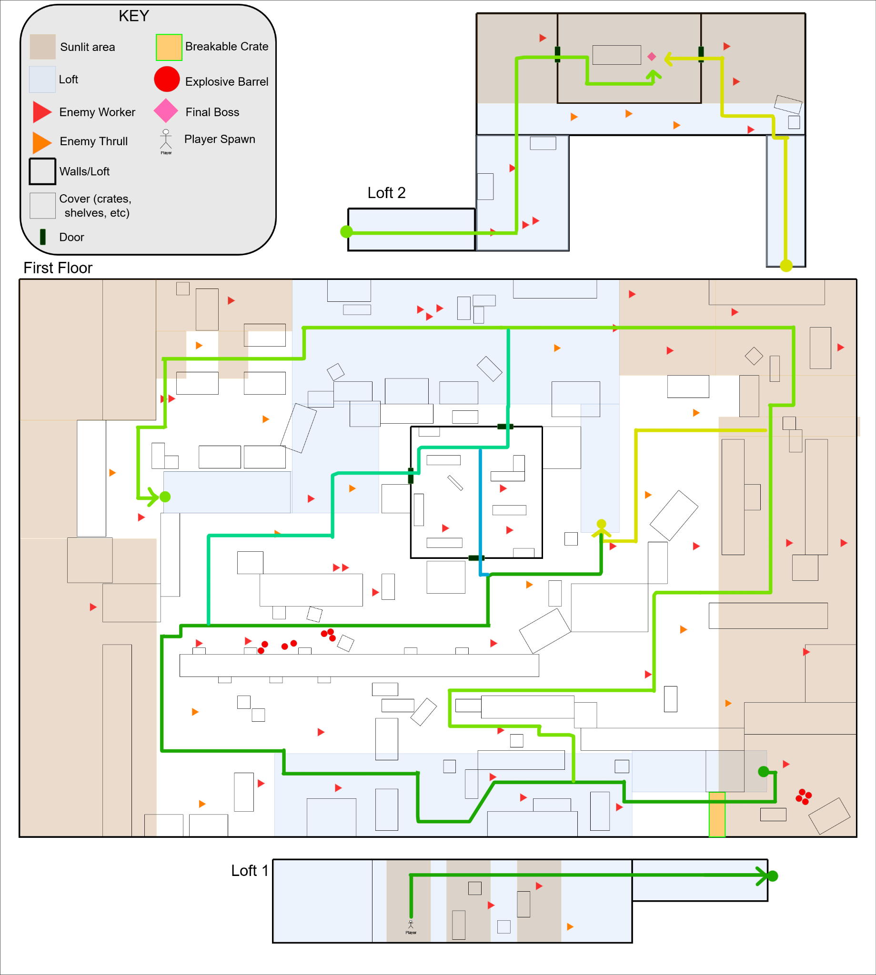

# User Interface

## Heads Up Display

**Gameplay HUD**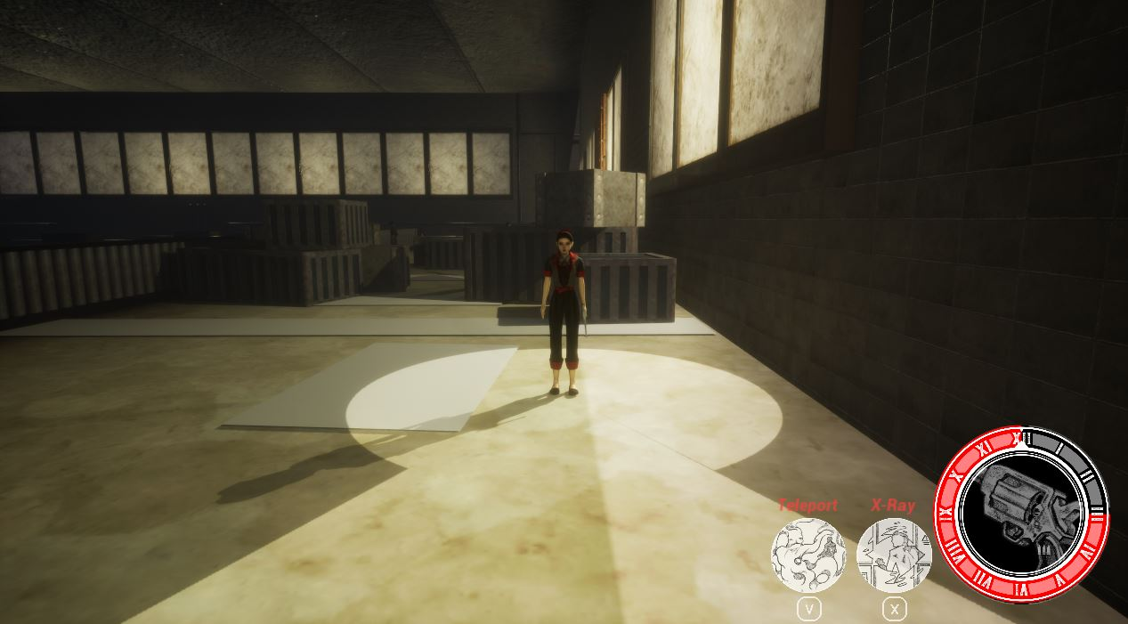

**Inventory UI**

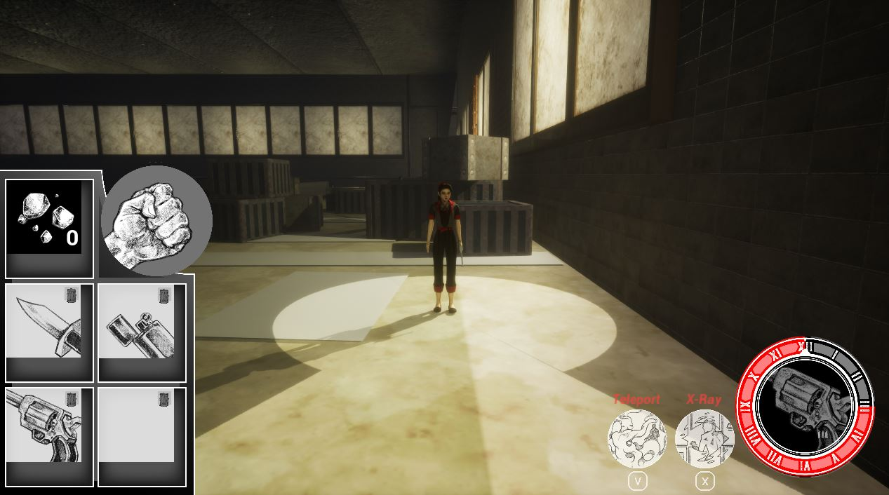

**Objective Tab**

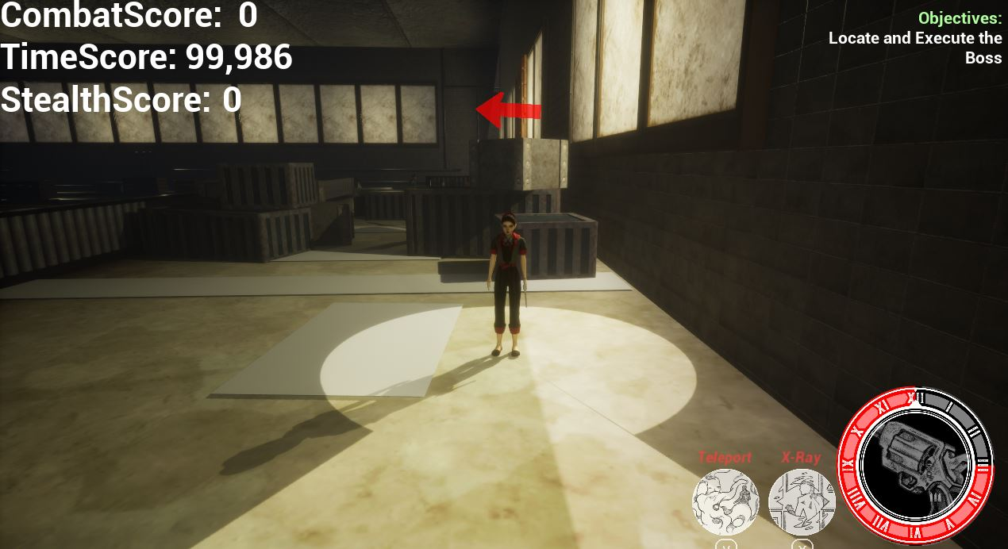

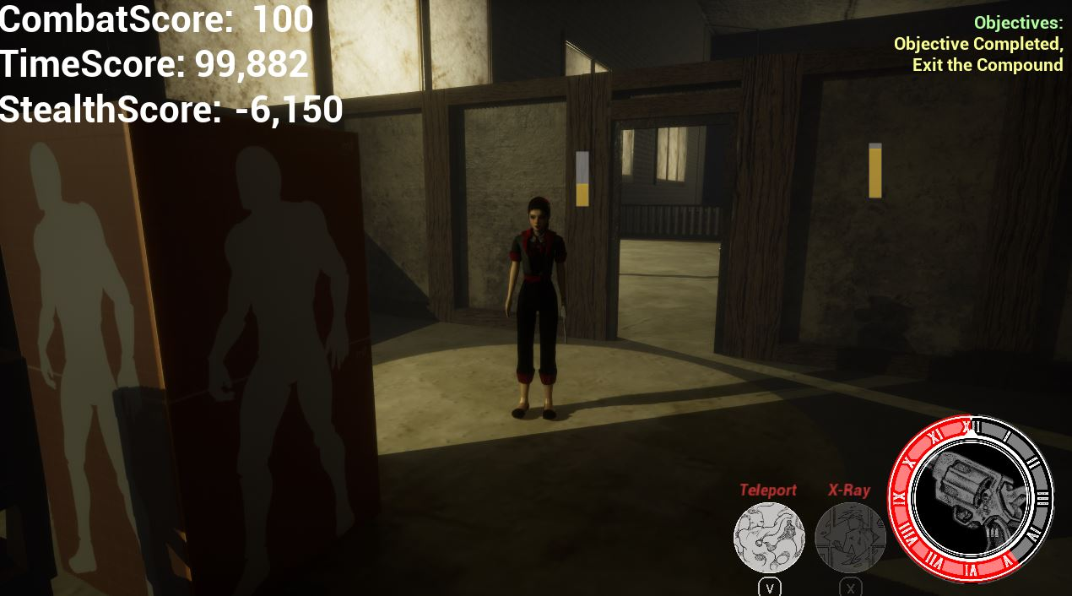

**Pause Menu**

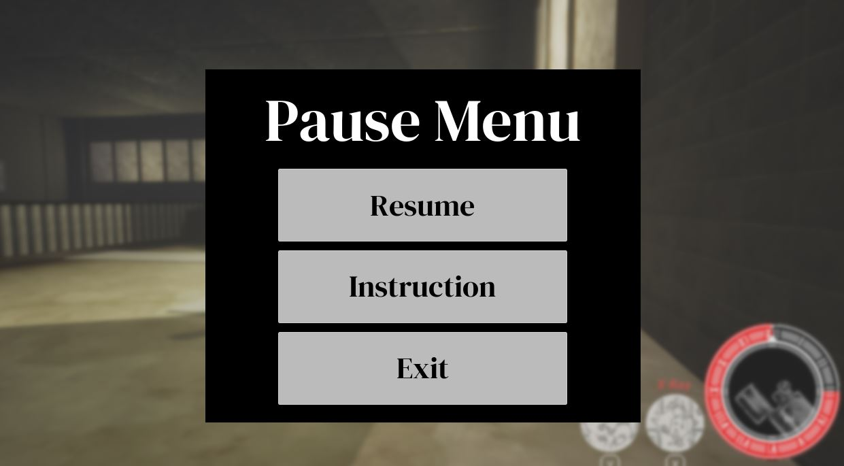

## Game Menus

**Title Screen**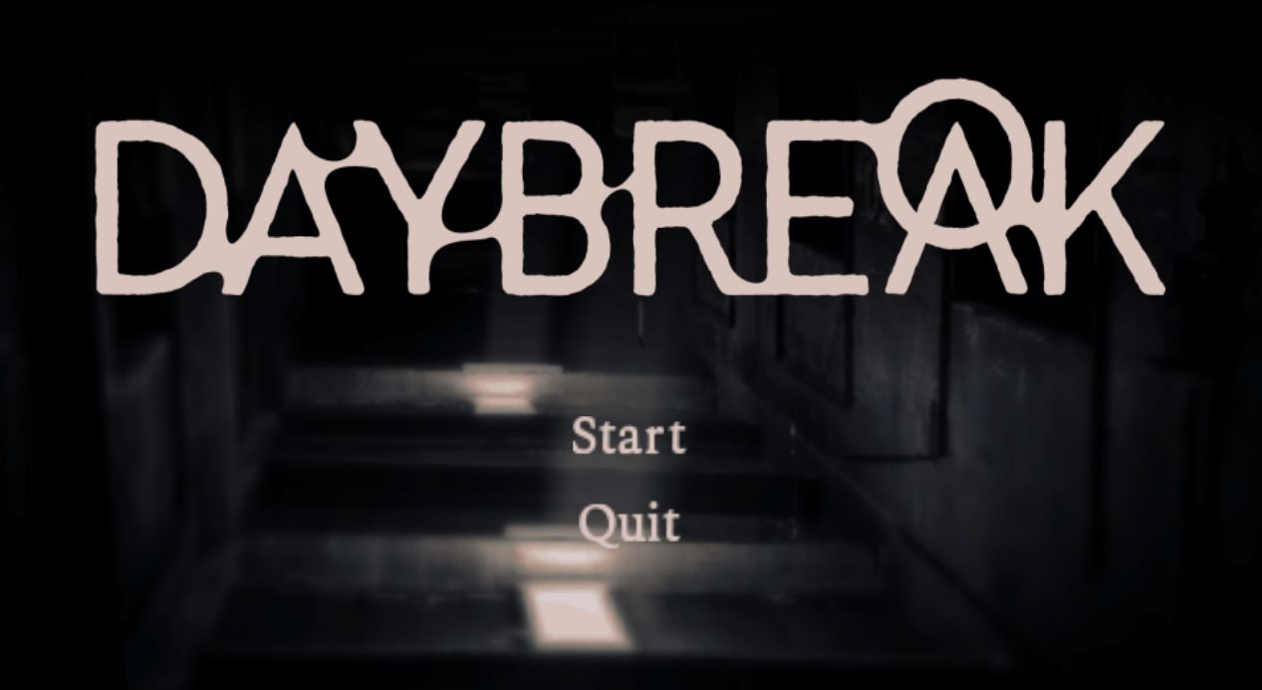

**Level Select**

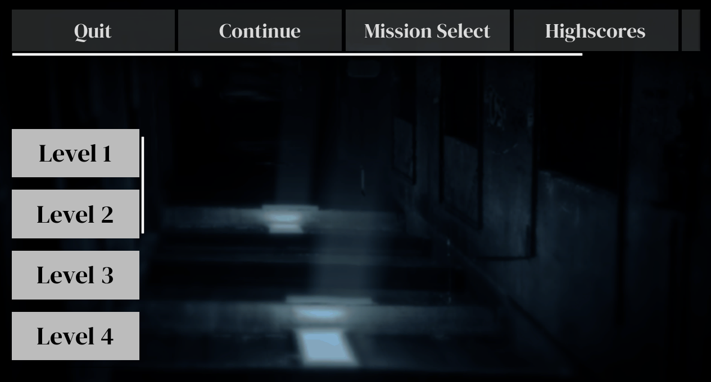

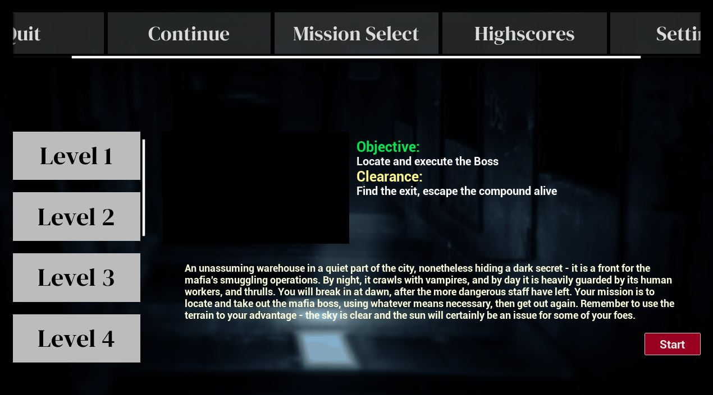

**Game Over Menu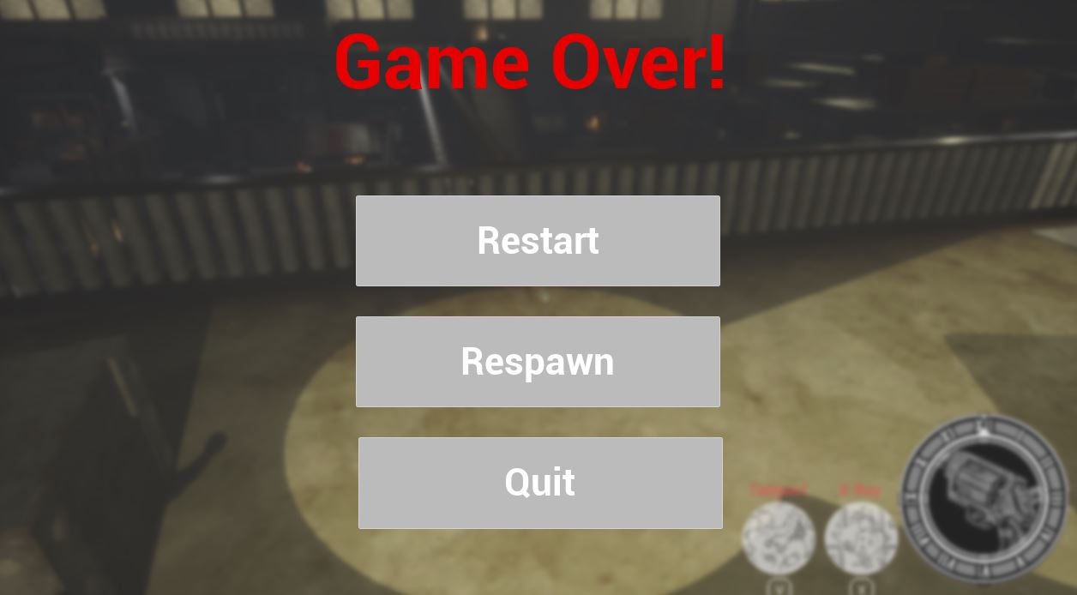Level Complete Screen**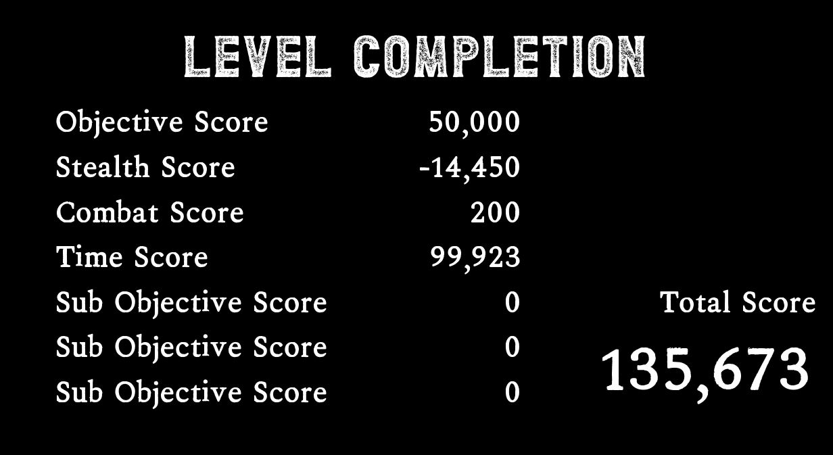

# Appendix

## Appendix A – Character Sketches

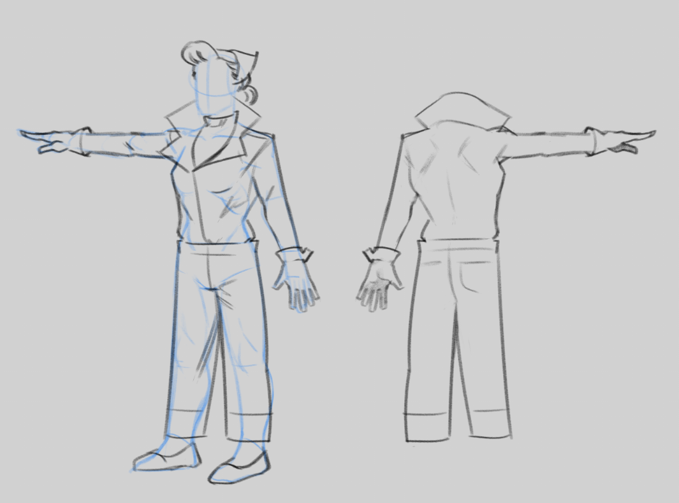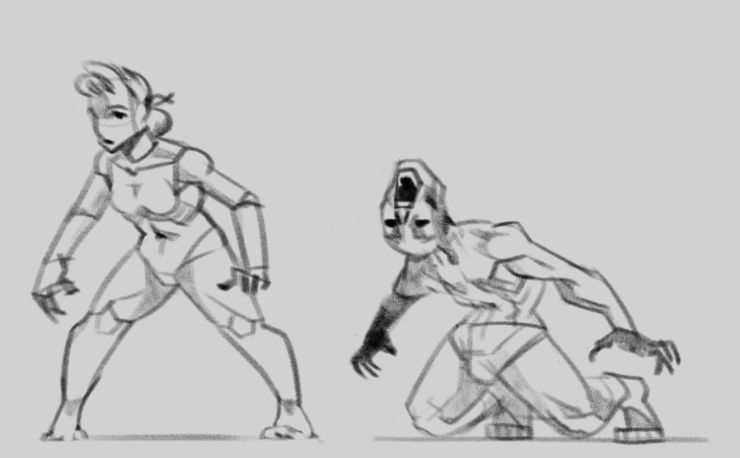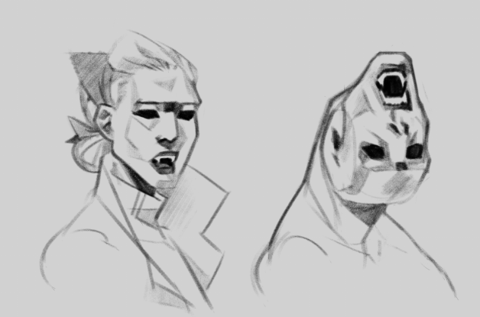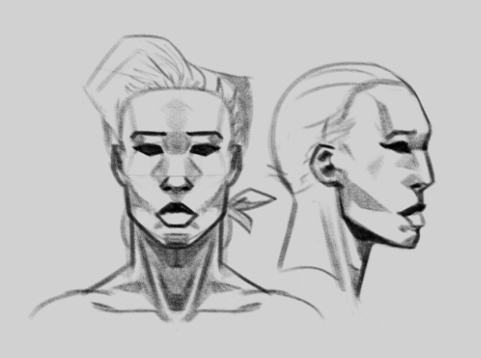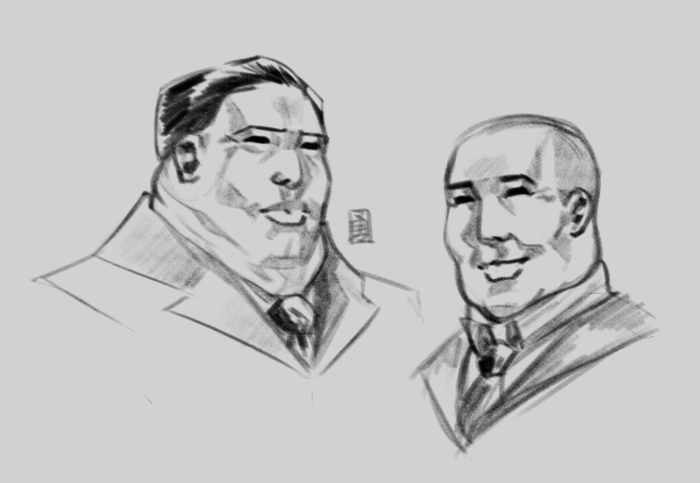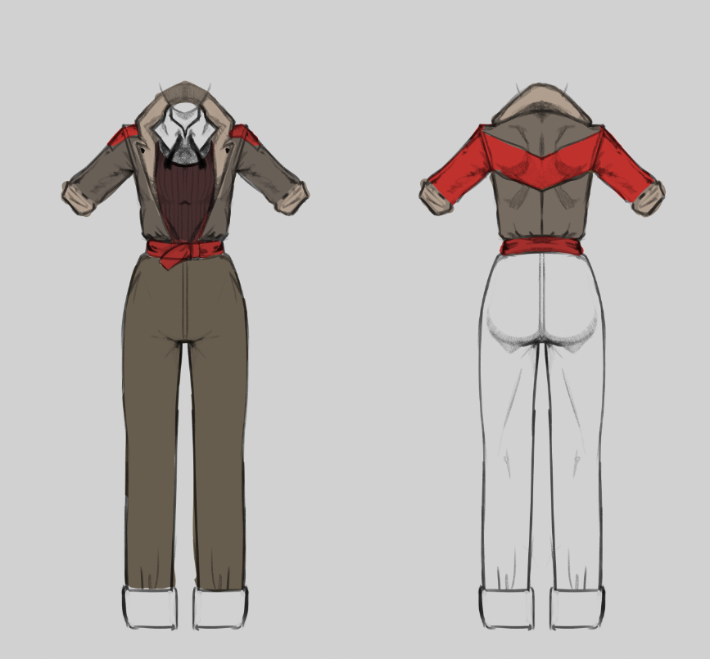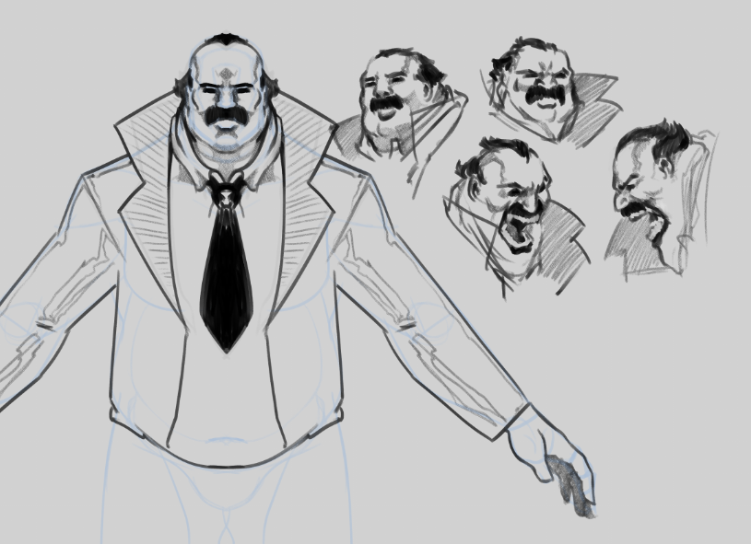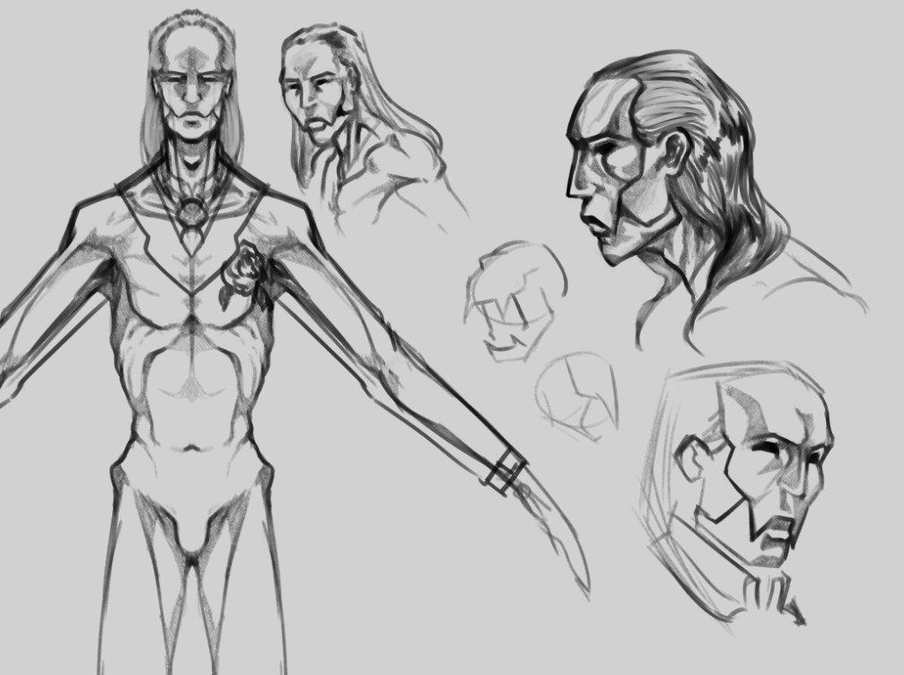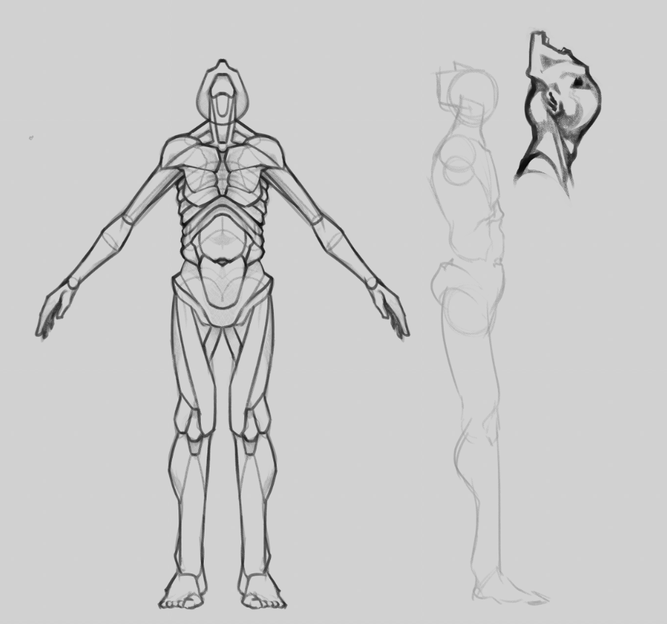

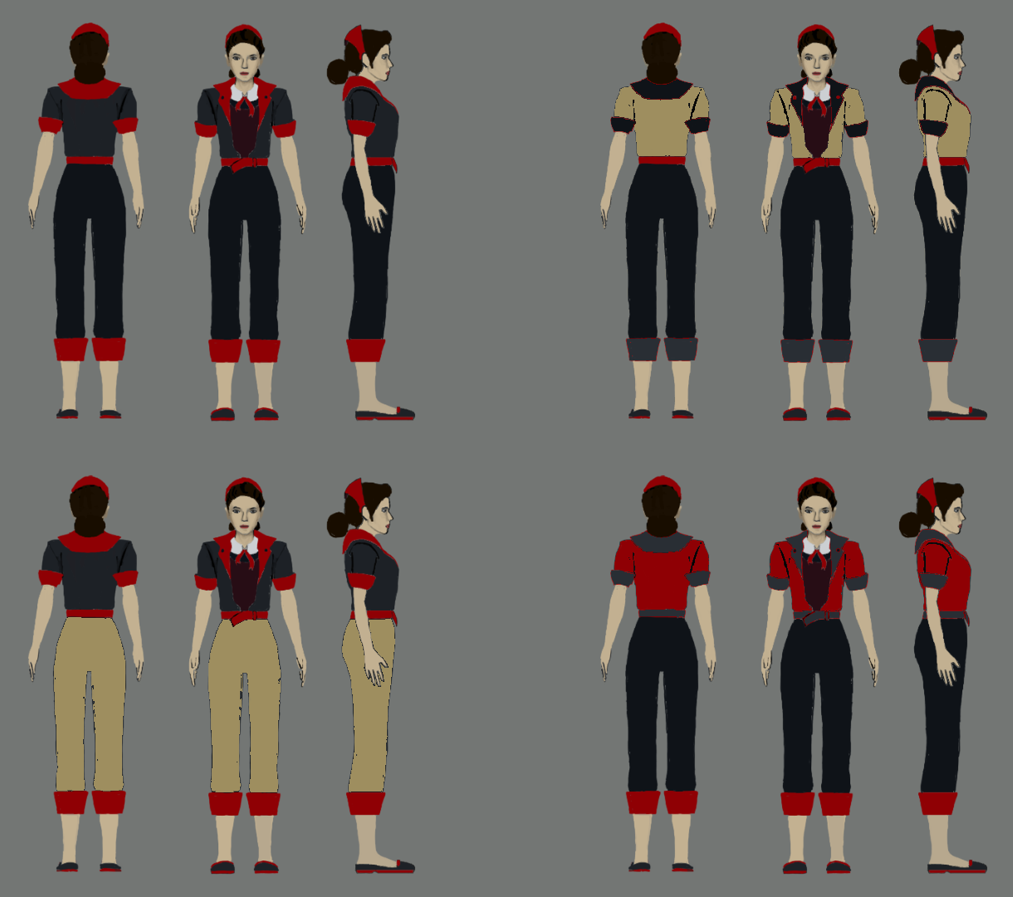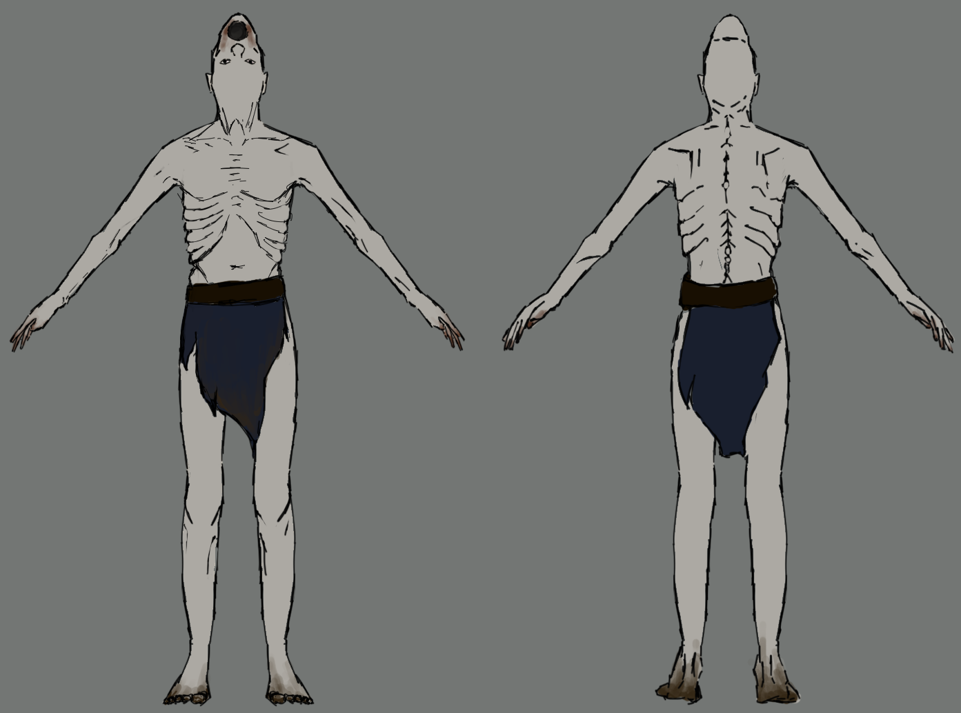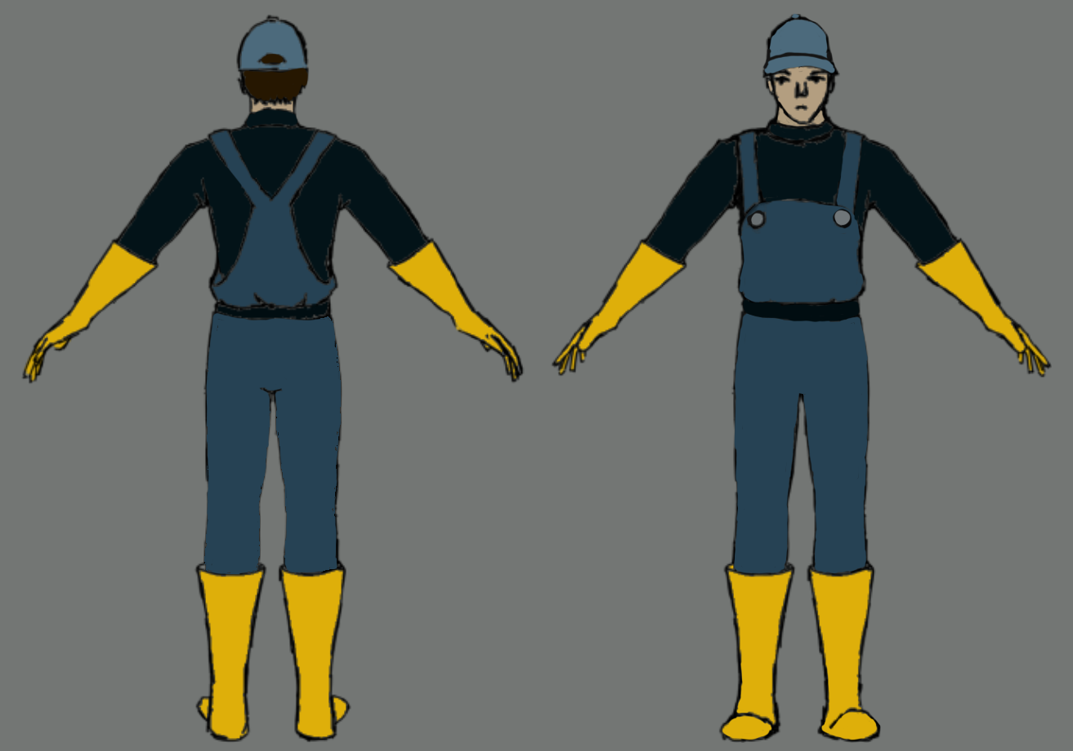

## Appendix B – Background Sketches

